Lab 8

# Establish a connection between two PC’s using Copper cross-over cable and transfer a message to each other using cisco packet tracer.

## Connection:

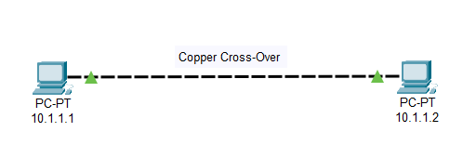

## Status:

# Establish a LAN network between four PC’s using a switch and transfer messages between them.

## Connection:

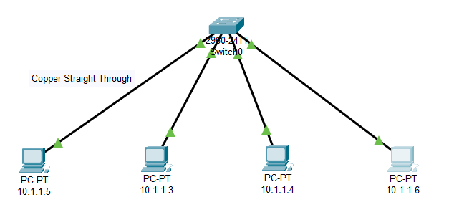

## Status:

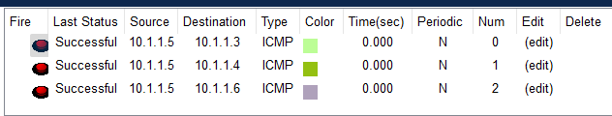

# Establish a connection between four PC’s using hub and transfer messages between them.

## Connection:

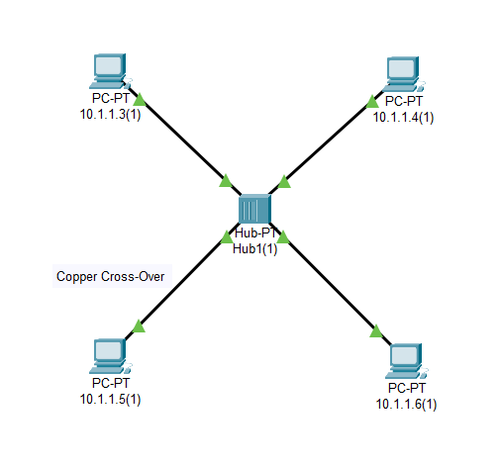

## Status:

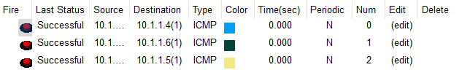

# Establish two LAN connection using hub and connect those two LAN connection using a switch and send messages back and forth between them.

## Connection:

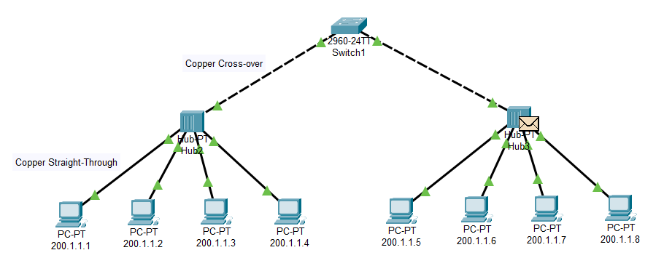

## Status:

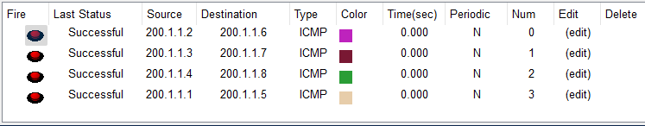

# Establish a connection between two PC’s using a router and transfer messages between them.

## Connection:

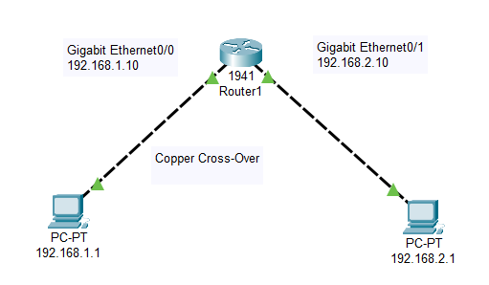

## Status:

